**HASIL PRAKTIKUM MODUL 8 BAHASA PEMROGRAMAN 1**

Nama : Ilham Hafidz

NIM : 20220810052

Kelas : TINFC-2022-01

POSTTEST :

1. Lengkapi program, jika tombol Edit di klik akan menampilkan message dialog YesNoQuestion untuk edit data

|  |
| --- |
| // berikut adalah tambahan program pada fungsi event mouse clicked button edit  private void buttonEditMouseClicked(java.awt.event.MouseEvent evt) {                                                 int confirmSelected= JOptionPane.showConfirmDialog(                 null,                 "Apakah Yakin Data Mahasiswa dengan NIM" + textFieldNIM.getText() + " akan diedit?",                 "Konfirmasi Edit",                 JOptionPane.YES_NO_OPTION             );                  if(confirmSelected == 0){             try {                 String jk= "";                 if(radioButtonPerempuan.isSelected()){                     jk= radioButtonPerempuan.getText();                 } else{                     jk= radioButtonLakiLaki.getText();                 }                  String sql_edit=                          "UPDATE mhs SET "                         + "nim='" + textFieldNIM.getText() + "', "                         + "nama= '" + textFieldNama.getText() + "', "                         + "jk= '" + jk + "', "                         + "prodi= '" + comboBoxProdi.getSelectedItem() + "', "                         + "alamat= '" + textAreaAlamat.getText() + "' , "                         + "kelas= '" + textFieldKelas.getText() + "' , "                         + "angkatan= '" + textFieldAngkatan.getText() + "' , "                         + "hp= '" + textFieldHP.getText() + "' "                         + "WHERE nim='" + textFieldNIM.getText() + "'";                  st.executeUpdate(sql_edit);                 JOptionPane.showMessageDialog(null, "Data mahasiswa berhasil di update");             } catch (SQLException e){                 JOptionPane.showMessageDialog(null, e);             }         } else{             JOptionPane.showMessageDialog(null, "Edit dibatalkan");         }     } |

Output :

* Kondisi Form awal

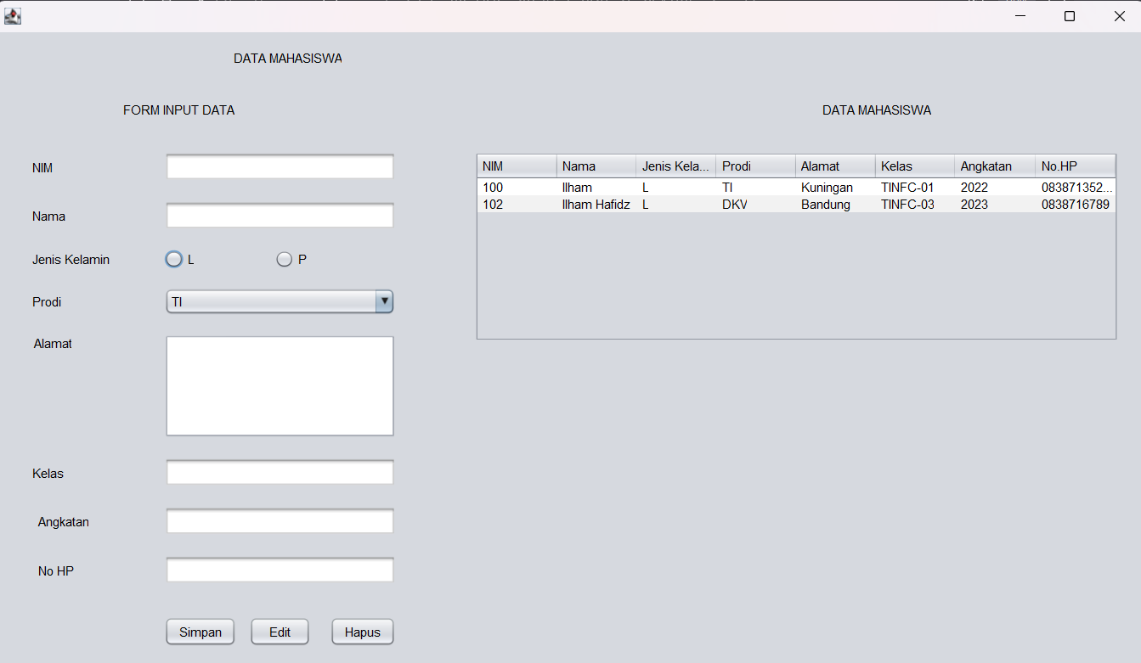

* Isi Form Edit Data

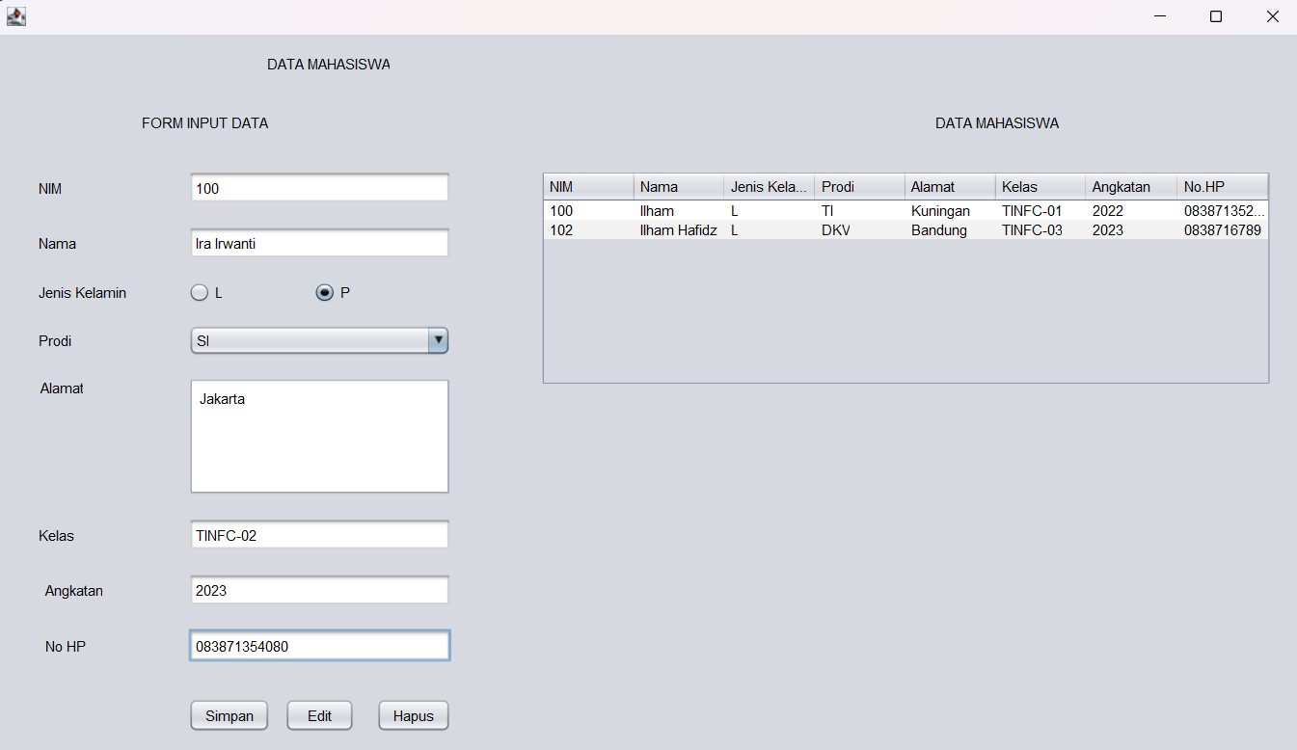

* Jika klik button edit

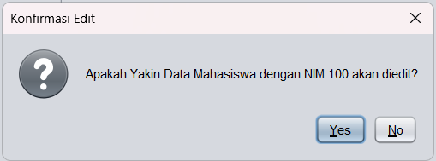

* Jika klik no pada pop up “konfirmasi edit” maka

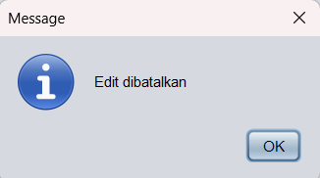

* Jika klik yes pada pop up “konfirmasi edit” maka

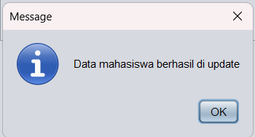

* Data berhasil di edit

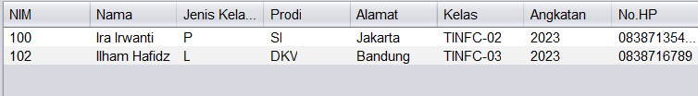

1. Lengkapi program, jika tombol Hapus di klik akan menampilkan message dialog YesNoQuestion untuk hapus data

|  |
| --- |
| // berikut adalah tambahan program pada fungsi event mouse clicked button hapus  private void buttonHapusMouseClicked(java.awt.event.MouseEvent evt) {                                                  int confirmDelete= JOptionPane.showConfirmDialog(                 null,                 "Apakah Yakin Data Mahasiswa dengan NIM " + textFieldNIM.getText() + " akan dihapus?",                 "Konfirmasi Hapus",                 JOptionPane.YES_NO_OPTION             );                  if(confirmDelete == 0){             try{                 st= koneksi.con.createStatement();                 String sql_delete = "DELETE FROM mhs WHERE nim= '" + textFieldNIM.getText() + "'";                                  st.executeUpdate(sql_delete);                                  JOptionPane.showMessageDialog(null, "Data berhasil dihapus");             } catch (SQLException e){                 JOptionPane.showMessageDialog(null, e);             }         } else{             JOptionPane.showMessageDialog(null, "Hapus dibatalkan");         }     } |

Output :

* Ketika mencoba menghapus data dengan klik tombol hapus

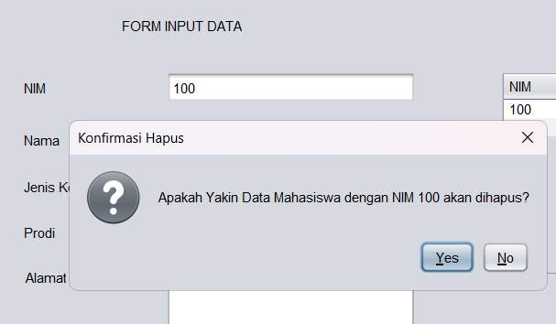

* Ketika klik no pada pop up “Konfirmasi Hapus”

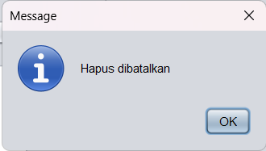

* Ketika klik yesy pada pop up “Konfirmasi Hapus”

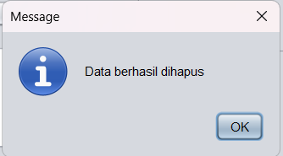

* Data berhasil dihapus

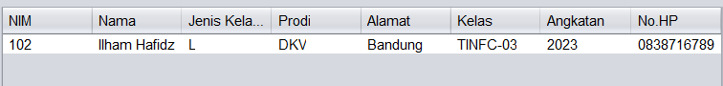

1. Lengkapi program, jika tombol Edit/Hapus di klik Form Input Data akan kembali kosong seperti kondisi awal.
2. Setelah edit/hapus, maka JTable akan melakukan Load Data

|  |
| --- |
| // untuk reset form dan load data, karena untuk reset form dan meload data sudah saya masukkan kedalam sebuah method, sehingga saya hanya cukup memanggil method reset() dan load_data() saja didalam   private void buttonEditMouseClicked(java.awt.event.MouseEvent evt) {                                                  int confirmSelected= JOptionPane.showConfirmDialog(                 null,                 "Apakah Yakin Data Mahasiswa dengan NIM " + textFieldNIM.getText() + " akan diedit?",                 "Konfirmasi Edit",                 JOptionPane.YES_NO_OPTION             );                  if(confirmSelected == 0){             try {                 String jk= "";                 if(radioButtonPerempuan.isSelected()){                     jk= radioButtonPerempuan.getText();                 } else{                     jk= radioButtonLakiLaki.getText();                 }                  String sql_edit=                          "UPDATE mhs SET "                         + "nim='" + textFieldNIM.getText() + "', "                         + "nama= '" + textFieldNama.getText() + "', "                         + "jk= '" + jk + "', "                         + "prodi= '" + comboBoxProdi.getSelectedItem() + "', "                         + "alamat= '" + textAreaAlamat.getText() + "' , "                         + "kelas= '" + textFieldKelas.getText() + "' , "                         + "angkatan= '" + textFieldAngkatan.getText() + "' , "                         + "hp= '" + textFieldHP.getText() + "' "                         + "WHERE nim='" + textFieldNIM.getText() + "'";                  st.executeUpdate(sql_edit);                 JOptionPane.showMessageDialog(null, "Data mahasiswa berhasil di update");                                  reset();                 load_data();             } catch (SQLException e){                 JOptionPane.showMessageDialog(null, e);             }         } else{             JOptionPane.showMessageDialog(null, "Edit dibatalkan");         }     }                                             private void buttonHapusMouseClicked(java.awt.event.MouseEvent evt) {                                                  int confirmDelete= JOptionPane.showConfirmDialog(                 null,                 "Apakah Yakin Data Mahasiswa dengan NIM " + textFieldNIM.getText() + " akan dihapus?",                 "Konfirmasi Hapus",                 JOptionPane.YES_NO_OPTION             );                  if(confirmDelete == 0){             try{                 st= koneksi.con.createStatement();                 String sql_delete = "DELETE FROM mhs WHERE nim= '" + textFieldNIM.getText() + "'";                                  st.executeUpdate(sql_delete);                                  JOptionPane.showMessageDialog(null, "Data berhasil dihapus");                                  reset();                 load_data();             } catch (SQLException e){                 JOptionPane.showMessageDialog(null, e);             }         } else{             JOptionPane.showMessageDialog(null, "Hapus dibatalkan");         }     } |

KESELURUHAN PROGRAM :

|  |
| --- |
| File : BP1_M8_IlhamHafidz.java |
| import java.sql.ResultSet;  import java.sql.Statement;  import javax.swing.JOptionPane;  import javax.swing.table.DefaultTableModel;  import java.sql.SQLException;  public class BP1_M8_IlhamHafidz extends javax.swing.JFrame {    Statement st;  ResultSet rs;  koneksi koneksi;  public BP1_M8_IlhamHafidz() {  koneksi= new koneksi();  initComponents();    load_data();  }    private void load_data(){  Object header[]= {"NIM", "Nama", "Jenis Kelamin", "Prodi", "Alamat", "Kelas", "Angkatan", "No.HP"};  DefaultTableModel data= new DefaultTableModel(null, header);  tableDataMahasiswa.setModel(data);    String sql= "SELECT * FROM mhs";    try{  st= koneksi.con.createStatement();  rs= st.executeQuery(sql);    while(rs.next()){  String k1= rs.getString(1);  String k2= rs.getString(2);  String k3= rs.getString(3);  String k4= rs.getString(4);  String k5= rs.getString(5);  String k6= rs.getString(6);  String k7= rs.getString(7);  String k8= rs.getString(8);    String k[]= {k1, k2, k3, k4, k5, k6, k7, k8};  data.addRow(k);  }  } catch(SQLException e) {  JOptionPane.showMessageDialog(null, e);  }  }    private void input_data(){  try {  String jk= "";  if(radioButtonPerempuan.isSelected()){  jk= radioButtonPerempuan.getText();  } else{  jk= radioButtonLakiLaki.getText();  }    String sql= "INSERT INTO mhs VALUES('"+  textFieldNIM.getText() + "', '" +  textFieldNama.getText() + "', '" +  jk + "', '" +  comboBoxProdi.getSelectedItem() + "', '" +  textAreaAlamat.getText() + "', '" +  textFieldKelas.getText() +"', '" +  textFieldAngkatan.getText() + "', '" +  textFieldHP.getText() + "')";    st.execute(sql);  load_data();    JOptionPane.showMessageDialog(null, "Data Mahasiswa Berhasil Diinput");  } catch (SQLException e){  JOptionPane.showMessageDialog(null, e);  }  }    private void reset(){  textFieldNIM.setText("");  textFieldNama.setText("");  comboBoxProdi.setSelectedItem("TI");  textAreaAlamat.setText("");  textFieldKelas.setText("");  textFieldAngkatan.setText("");  textFieldHP.setText("");  }    private void check(){  String nim= textFieldNIM.getText();  String nama= textFieldNama.getText();  String kelas= textFieldKelas.getText();  String angkatan= textFieldAngkatan.getText();  String hp= textFieldHP.getText();  String alamat = textAreaAlamat.getText();    if(  nim.equals("") ||  nama.equals("") ||  kelas.equals("") ||  angkatan.equals("") ||  hp.equals("") ||  alamat.equals("")  ){  JOptionPane.showMessageDialog(  null,  "Harap isi semua inputan",  "Tambah Data Gagal",  JOptionPane.ERROR_MESSAGE  );  } else{  input_data();  }  }    @SuppressWarnings("unchecked")  // <editor-fold defaultstate="collapsed" desc="Generated Code">  private void initComponents() {  labelTitle = new javax.swing.JLabel();  labelSubtitle = new javax.swing.JLabel();  labelNIM = new javax.swing.JLabel();  labelNama = new javax.swing.JLabel();  labelJenisKelamin = new javax.swing.JLabel();  labelProdi = new javax.swing.JLabel();  labelAlamat = new javax.swing.JLabel();  textFieldNIM = new javax.swing.JTextField();  textFieldNama = new javax.swing.JTextField();  jScrollPane1 = new javax.swing.JScrollPane();  textAreaAlamat = new javax.swing.JTextArea();  comboBoxProdi = new javax.swing.JComboBox<>();  radioButtonLakiLaki = new javax.swing.JRadioButton();  radioButtonPerempuan = new javax.swing.JRadioButton();  buttonSimpan = new javax.swing.JButton();  jLabel1 = new javax.swing.JLabel();  jScrollPane2 = new javax.swing.JScrollPane();  tableDataMahasiswa = new javax.swing.JTable();  labelKelas = new javax.swing.JLabel();  textFieldKelas = new javax.swing.JTextField();  labelAngkatan = new javax.swing.JLabel();  textFieldAngkatan = new javax.swing.JTextField();  labelNoHP = new javax.swing.JLabel();  textFieldHP = new javax.swing.JTextField();  buttonEdit = new javax.swing.JButton();  buttonHapus = new javax.swing.JButton();  setDefaultCloseOperation(javax.swing.WindowConstants.EXIT_ON_CLOSE);  labelTitle.setText("DATA MAHASISWA");  labelSubtitle.setText("FORM INPUT DATA");  labelNIM.setText("NIM");  labelNama.setText("Nama");  labelJenisKelamin.setText("Jenis Kelamin");  labelProdi.setText("Prodi");  labelAlamat.setText("Alamat");  textAreaAlamat.setColumns(20);  textAreaAlamat.setRows(5);  textAreaAlamat.setPreferredSize(new java.awt.Dimension(60, 84));  jScrollPane1.setViewportView(textAreaAlamat);  comboBoxProdi.setModel(new javax.swing.DefaultComboBoxModel<>(new String[] { "TI", "SI", "DKV", "MI", "TS", " " }));  radioButtonLakiLaki.setText("L");  radioButtonPerempuan.setText("P");  buttonSimpan.setText("Simpan");  buttonSimpan.addMouseListener(new java.awt.event.MouseAdapter() {  public void mouseClicked(java.awt.event.MouseEvent evt) {  buttonSimpanMouseClicked(evt);  }  });  jLabel1.setText("DATA MAHASISWA");  tableDataMahasiswa.setModel(new javax.swing.table.DefaultTableModel(  new Object [][] {  {null, null, null, null},  {null, null, null, null},  {null, null, null, null},  {null, null, null, null}  },  new String [] {  "Title 1", "Title 2", "Title 3", "Title 4"  }  ));  jScrollPane2.setViewportView(tableDataMahasiswa);  labelKelas.setText("Kelas");  labelAngkatan.setText("Angkatan");  labelNoHP.setText("No HP");  buttonEdit.setText("Edit");  buttonEdit.addMouseListener(new java.awt.event.MouseAdapter() {  public void mouseClicked(java.awt.event.MouseEvent evt) {  buttonEditMouseClicked(evt);  }  });  buttonHapus.setText("Hapus");  buttonHapus.addMouseListener(new java.awt.event.MouseAdapter() {  public void mouseClicked(java.awt.event.MouseEvent evt) {  buttonHapusMouseClicked(evt);  }  });  javax.swing.GroupLayout layout = new javax.swing.GroupLayout(getContentPane());  getContentPane().setLayout(layout);  layout.setHorizontalGroup(  layout.createParallelGroup(javax.swing.GroupLayout.Alignment.LEADING)  .addGroup(layout.createSequentialGroup()  .addGap(223, 223, 223)  .addComponent(labelTitle)  .addContainerGap(javax.swing.GroupLayout.DEFAULT_SIZE, Short.MAX_VALUE))  .addGroup(layout.createSequentialGroup()  .addGroup(layout.createParallelGroup(javax.swing.GroupLayout.Alignment.LEADING)  .addGroup(layout.createSequentialGroup()  .addGap(119, 119, 119)  .addComponent(labelSubtitle))  .addGroup(layout.createSequentialGroup()  .addGroup(layout.createParallelGroup(javax.swing.GroupLayout.Alignment.LEADING)  .addGroup(layout.createSequentialGroup()  .addGap(34, 34, 34)  .addGroup(layout.createParallelGroup(javax.swing.GroupLayout.Alignment.LEADING)  .addComponent(labelNIM, javax.swing.GroupLayout.PREFERRED_SIZE, 37, javax.swing.GroupLayout.PREFERRED_SIZE)  .addComponent(labelNama, javax.swing.GroupLayout.PREFERRED_SIZE, 37, javax.swing.GroupLayout.PREFERRED_SIZE)  .addComponent(labelProdi, javax.swing.GroupLayout.PREFERRED_SIZE, 37, javax.swing.GroupLayout.PREFERRED_SIZE)  .addComponent(labelJenisKelamin)  .addGroup(layout.createParallelGroup(javax.swing.GroupLayout.Alignment.TRAILING)  .addComponent(labelKelas, javax.swing.GroupLayout.PREFERRED_SIZE, 37, javax.swing.GroupLayout.PREFERRED_SIZE)  .addComponent(labelAlamat)))  .addGap(51, 51, 51))  .addGroup(javax.swing.GroupLayout.Alignment.TRAILING, layout.createSequentialGroup()  .addContainerGap()  .addGroup(layout.createParallelGroup(javax.swing.GroupLayout.Alignment.LEADING)  .addComponent(labelNoHP, javax.swing.GroupLayout.PREFERRED_SIZE, 37, javax.swing.GroupLayout.PREFERRED_SIZE)  .addComponent(labelAngkatan))  .addGap(71, 71, 71)))  .addGroup(layout.createParallelGroup(javax.swing.GroupLayout.Alignment.LEADING, false)  .addGroup(layout.createSequentialGroup()  .addComponent(radioButtonLakiLaki, javax.swing.GroupLayout.PREFERRED_SIZE, 98, javax.swing.GroupLayout.PREFERRED_SIZE)  .addPreferredGap(javax.swing.LayoutStyle.ComponentPlacement.RELATED)  .addComponent(radioButtonPerempuan, javax.swing.GroupLayout.PREFERRED_SIZE, 98, javax.swing.GroupLayout.PREFERRED_SIZE))  .addComponent(textFieldNama)  .addComponent(textFieldNIM)  .addComponent(jScrollPane1)  .addComponent(comboBoxProdi, 0, javax.swing.GroupLayout.DEFAULT_SIZE, Short.MAX_VALUE)  .addGroup(layout.createSequentialGroup()  .addComponent(buttonSimpan)  .addPreferredGap(javax.swing.LayoutStyle.ComponentPlacement.UNRELATED)  .addComponent(buttonEdit, javax.swing.GroupLayout.DEFAULT_SIZE, javax.swing.GroupLayout.DEFAULT_SIZE, Short.MAX_VALUE)  .addGap(18, 18, 18)  .addComponent(buttonHapus))  .addComponent(textFieldKelas)  .addComponent(textFieldAngkatan)  .addComponent(textFieldHP))))  .addPreferredGap(javax.swing.LayoutStyle.ComponentPlacement.RELATED, 74, Short.MAX_VALUE)  .addGroup(layout.createParallelGroup(javax.swing.GroupLayout.Alignment.LEADING)  .addGroup(javax.swing.GroupLayout.Alignment.TRAILING, layout.createSequentialGroup()  .addComponent(jLabel1)  .addGap(202, 202, 202))  .addGroup(javax.swing.GroupLayout.Alignment.TRAILING, layout.createSequentialGroup()  .addComponent(jScrollPane2, javax.swing.GroupLayout.PREFERRED_SIZE, 607, javax.swing.GroupLayout.PREFERRED_SIZE)  .addGap(25, 25, 25))))  );  layout.setVerticalGroup(  layout.createParallelGroup(javax.swing.GroupLayout.Alignment.LEADING)  .addGroup(layout.createSequentialGroup()  .addGap(16, 16, 16)  .addComponent(labelTitle)  .addGap(33, 33, 33)  .addGroup(layout.createParallelGroup(javax.swing.GroupLayout.Alignment.BASELINE)  .addComponent(labelSubtitle)  .addComponent(jLabel1))  .addGap(32, 32, 32)  .addGroup(layout.createParallelGroup(javax.swing.GroupLayout.Alignment.LEADING)  .addComponent(jScrollPane2, javax.swing.GroupLayout.PREFERRED_SIZE, 179, javax.swing.GroupLayout.PREFERRED_SIZE)  .addGroup(layout.createSequentialGroup()  .addGroup(layout.createParallelGroup(javax.swing.GroupLayout.Alignment.BASELINE)  .addComponent(labelNIM)  .addComponent(textFieldNIM, javax.swing.GroupLayout.PREFERRED_SIZE, javax.swing.GroupLayout.DEFAULT_SIZE, javax.swing.GroupLayout.PREFERRED_SIZE))  .addGap(18, 18, 18)  .addGroup(layout.createParallelGroup(javax.swing.GroupLayout.Alignment.BASELINE)  .addComponent(labelNama)  .addComponent(textFieldNama, javax.swing.GroupLayout.PREFERRED_SIZE, javax.swing.GroupLayout.DEFAULT_SIZE, javax.swing.GroupLayout.PREFERRED_SIZE))  .addGap(18, 18, 18)  .addGroup(layout.createParallelGroup(javax.swing.GroupLayout.Alignment.BASELINE)  .addComponent(labelJenisKelamin)  .addComponent(radioButtonLakiLaki)  .addComponent(radioButtonPerempuan))  .addGap(18, 18, 18)  .addGroup(layout.createParallelGroup(javax.swing.GroupLayout.Alignment.BASELINE)  .addComponent(labelProdi)  .addComponent(comboBoxProdi, javax.swing.GroupLayout.PREFERRED_SIZE, javax.swing.GroupLayout.DEFAULT_SIZE, javax.swing.GroupLayout.PREFERRED_SIZE))  .addGap(18, 18, 18)  .addGroup(layout.createParallelGroup(javax.swing.GroupLayout.Alignment.LEADING)  .addComponent(labelAlamat)  .addComponent(jScrollPane1, javax.swing.GroupLayout.PREFERRED_SIZE, javax.swing.GroupLayout.DEFAULT_SIZE, javax.swing.GroupLayout.PREFERRED_SIZE))  .addGap(18, 18, 18)  .addGroup(layout.createParallelGroup(javax.swing.GroupLayout.Alignment.BASELINE)  .addComponent(textFieldKelas, javax.swing.GroupLayout.PREFERRED_SIZE, javax.swing.GroupLayout.DEFAULT_SIZE, javax.swing.GroupLayout.PREFERRED_SIZE)  .addComponent(labelKelas))))  .addGap(18, 18, 18)  .addGroup(layout.createParallelGroup(javax.swing.GroupLayout.Alignment.BASELINE)  .addComponent(labelAngkatan)  .addComponent(textFieldAngkatan, javax.swing.GroupLayout.PREFERRED_SIZE, javax.swing.GroupLayout.DEFAULT_SIZE, javax.swing.GroupLayout.PREFERRED_SIZE))  .addGap(18, 18, 18)  .addGroup(layout.createParallelGroup(javax.swing.GroupLayout.Alignment.BASELINE)  .addComponent(labelNoHP)  .addComponent(textFieldHP, javax.swing.GroupLayout.PREFERRED_SIZE, javax.swing.GroupLayout.DEFAULT_SIZE, javax.swing.GroupLayout.PREFERRED_SIZE))  .addPreferredGap(javax.swing.LayoutStyle.ComponentPlacement.RELATED, 30, Short.MAX_VALUE)  .addGroup(layout.createParallelGroup(javax.swing.GroupLayout.Alignment.BASELINE)  .addComponent(buttonSimpan)  .addComponent(buttonEdit)  .addComponent(buttonHapus))  .addGap(20, 20, 20))  );  pack();  }// </editor-fold>  private void buttonSimpanMouseClicked(java.awt.event.MouseEvent evt) {  int confirmSelected= JOptionPane.showConfirmDialog(  null,  "Apakah Yakin Data Mahasiswa akan ditambahkan?",  "Konfirmasi",  JOptionPane.YES_NO_OPTION  );    if(confirmSelected == 0){  check();  }    reset();  }  private void buttonEditMouseClicked(java.awt.event.MouseEvent evt) {  int confirmSelected= JOptionPane.showConfirmDialog(  null,  "Apakah Yakin Data Mahasiswa dengan NIM " + textFieldNIM.getText() + " akan diedit?",  "Konfirmasi Edit",  JOptionPane.YES_NO_OPTION  );    if(confirmSelected == 0){  try {  String jk= "";  if(radioButtonPerempuan.isSelected()){  jk= radioButtonPerempuan.getText();  } else{  jk= radioButtonLakiLaki.getText();  }  String sql_edit=  "UPDATE mhs SET "  + "nim='" + textFieldNIM.getText() + "', "  + "nama= '" + textFieldNama.getText() + "', "  + "jk= '" + jk + "', "  + "prodi= '" + comboBoxProdi.getSelectedItem() + "', "  + "alamat= '" + textAreaAlamat.getText() + "' , "  + "kelas= '" + textFieldKelas.getText() + "' , "  + "angkatan= '" + textFieldAngkatan.getText() + "' , "  + "hp= '" + textFieldHP.getText() + "' "  + "WHERE nim='" + textFieldNIM.getText() + "'";  st.executeUpdate(sql_edit);  JOptionPane.showMessageDialog(null, "Data mahasiswa berhasil di update");    reset();  load_data();  } catch (SQLException e){  JOptionPane.showMessageDialog(null, e);  }  } else{  JOptionPane.showMessageDialog(null, "Edit dibatalkan");  }  }  private void buttonHapusMouseClicked(java.awt.event.MouseEvent evt) {  int confirmDelete= JOptionPane.showConfirmDialog(  null,  "Apakah Yakin Data Mahasiswa dengan NIM " + textFieldNIM.getText() + " akan dihapus?",  "Konfirmasi Hapus",  JOptionPane.YES_NO_OPTION  );    if(confirmDelete == 0){  try{  st= koneksi.con.createStatement();  String sql_delete = "DELETE FROM mhs WHERE nim= '" + textFieldNIM.getText() + "'";    st.executeUpdate(sql_delete);    JOptionPane.showMessageDialog(null, "Data berhasil dihapus");    reset();  load_data();  } catch (SQLException e){  JOptionPane.showMessageDialog(null, e);  }  } else{  JOptionPane.showMessageDialog(null, "Hapus dibatalkan");  }  }  public static void main(String args[]) {  try {  for (javax.swing.UIManager.LookAndFeelInfo info : javax.swing.UIManager.getInstalledLookAndFeels()) {  if ("Nimbus".equals(info.getName())) {  javax.swing.UIManager.setLookAndFeel(info.getClassName());  break;  }  }  } catch (ClassNotFoundException ex) {  java.util.logging.Logger.getLogger(BP1_M8_IlhamHafidz.class.getName()).log(java.util.logging.Level.SEVERE, null, ex);  } catch (InstantiationException ex) {  java.util.logging.Logger.getLogger(BP1_M8_IlhamHafidz.class.getName()).log(java.util.logging.Level.SEVERE, null, ex);  } catch (IllegalAccessException ex) {  java.util.logging.Logger.getLogger(BP1_M8_IlhamHafidz.class.getName()).log(java.util.logging.Level.SEVERE, null, ex);  } catch (javax.swing.UnsupportedLookAndFeelException ex) {  java.util.logging.Logger.getLogger(BP1_M8_IlhamHafidz.class.getName()).log(java.util.logging.Level.SEVERE, null, ex);  }  java.awt.EventQueue.invokeLater(new Runnable() {  public void run() {  new BP1_M8_IlhamHafidz().setVisible(true);  }  });  }  // Variables declaration - do not modify  private javax.swing.JButton buttonEdit;  private javax.swing.JButton buttonHapus;  private javax.swing.JButton buttonSimpan;  private javax.swing.JComboBox<String> comboBoxProdi;  private javax.swing.JLabel jLabel1;  private javax.swing.JScrollPane jScrollPane1;  private javax.swing.JScrollPane jScrollPane2;  private javax.swing.JLabel labelAlamat;  private javax.swing.JLabel labelAngkatan;  private javax.swing.JLabel labelJenisKelamin;  private javax.swing.JLabel labelKelas;  private javax.swing.JLabel labelNIM;  private javax.swing.JLabel labelNama;  private javax.swing.JLabel labelNoHP;  private javax.swing.JLabel labelProdi;  private javax.swing.JLabel labelSubtitle;  private javax.swing.JLabel labelTitle;  private javax.swing.JRadioButton radioButtonLakiLaki;  private javax.swing.JRadioButton radioButtonPerempuan;  private javax.swing.JTable tableDataMahasiswa;  private javax.swing.JTextArea textAreaAlamat;  private javax.swing.JTextField textFieldAngkatan;  private javax.swing.JTextField textFieldHP;  private javax.swing.JTextField textFieldKelas;  private javax.swing.JTextField textFieldNIM;  private javax.swing.JTextField textFieldNama;  // End of variables declaration  } |